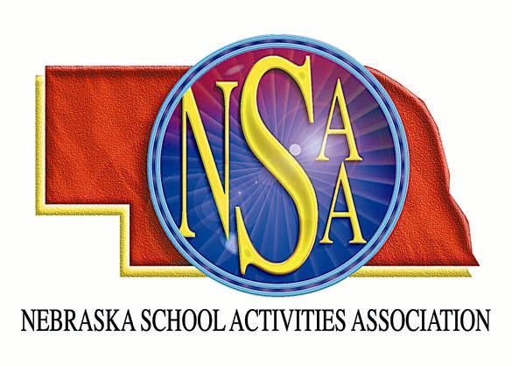
MOA/NSAA FOOTBALL
OFFICIALS’ CLINIC

The Midwest Officials Association and Nebraska School Activities Association will sponsor a football officiating clinic at Buell Stadium in Millard. There will be schools conducting intra-squad scrimmages in the morning. Officials should come prepared to officiate. Knickers and socks are not required. Attendees will be divided into two groups for the morning sessions. Each group will have field time and classroom time. We will make every effort to accommodate crews. NSAA observers and staff will be in attendance.

Saturday, August 14, 2010
Check In: 7:30 am – 8:00 am
Position Meeting: 8:00 am – 9:00 am
Scrimmage I/Classroom I: 9:00 am – 10:30 am
Scrimmage II/Classroom II: 11:00 am – 12:30 pm
Round Table Discussion and Lunch (Provided): 12:30 pm – 1:30 pm

$30.00 Before July 23
$35.00 After August 1
Preregistration is required.

Complete the registration form with all the necessary information and enclose payment of $35.00.
The fee is non-refundable. Return by August 12, 2010 as SPACE IS LIMITED!

_________________________________________________________________________________________________

Name:_____________________________________ Address:___________________________________

City, State, Zip:______________________________ Telephone #:________________________________

E-mail:_____________________________________ Position:____________________________________

MAIL TO: NSAA
PO Box 85448
Lincoln, NE 68501-5448
